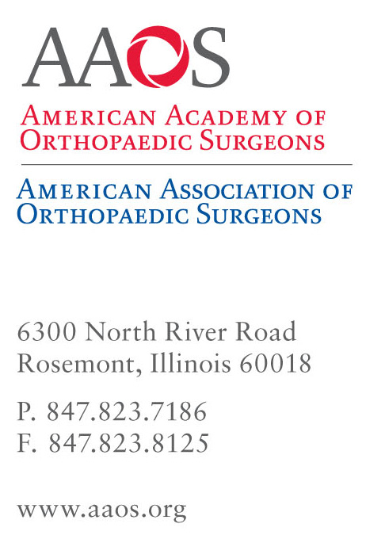
November 1, 2007
BOARD OF DIRECTORS
PRESIDENT
James H. Beaty, MD
Memphis, Tennessee
FIRST VICE PRESIDENT
E. Anthony Rankin, MD
Washington, DC
SECOND VICE PRESIDENT
Joseph D. Zuckerman, MD
New York, New York
TREASURER
William L. Healy, MD
Burlington, Massachusetts
PAST PRESIDENT
Richard F. Kyle, MD
Minneapolis, Minnesota
CHAIR
BOARD OF COUNCILORS
Matthew S. Shapiro, MD
Eugene, Oregon
CHAIR-ELECT
BOARD OF COUNCILORS
John T. Gill, MD
Dallas, Texas
SECRETARY
BOARD OF COUNCILORS
Thomas C. Barber, MD
Oakland, California
CHAIR
BOARD OF SPECIALTY SOCIETIES
Joseph C. McCarthy, MD
Boston, Massachusetts
CHAIR-ELECT
BOARD OF SPECIALTY SOCIETIES
James P. Tasto, MD
San Diego, California
SECRETARY
BOARD OF SPECIALTY SOCIETIES
William J. Robb, III, MD
Evanston, Illinois
LAY MEMBER
George Zachary Wilhoit, MS, MBA
South Hackensack, New Jersey
MEMBERS-AT-LARGE
Kevin J. Bozic, MD, MBA
San Francisco, California
Christopher D. Harner, MD
Pittsburgh, Pennsylvania
Norman Otsuka, MD
Los Angeles, California
Ken Yamaguchi, MD
Saint Louis, Missouri
CHIEF EXECUTIVE OFFICER
(Ex-Officio)
Karen L. Hackett, FACHE, CAE
Rosemont, Illinois

Dear Colleague:

Recently, in order to comply with settlement agreements with the US Attorney of New Jersey (Department of Justice or DOJ), five orthopaedic hip and knee manufacturers disclosed the names and certain financial information about physicians with whom they have had a financial relationship in 2007.

At the end of November, these five implant manufacturers are expected to release additional information that will include the names of physicians who received in-kind contributions, such as meals, travel, and other non-cash remuneration.

AAOS supports appropriate financial disclosures to patients regarding relationships between orthopaedic surgeons and implant manufacturers. The priority of AAOS members is the care and well being of their patients. We are committed to making sure that patients and the public have confidence that partnerships between companies and physicians put the interests of patients first.

Many of our AAOS colleagues choose to work in partnership with implant manufacturers to provide consulting advice, conduct research, and educate orthopaedic surgeons and the public. A number of AAOS members are engaged in developing new medical devices to better serve patient needs. The appearance of a physician’s name on any disclosure filing referenced above indicates only that he or she has received compensation from the implant manufacturer.

AAOS Leadership
During the past month, the AAOS Board of Directors and leadership have spent considerable time and effort discussing the settlement agreements, and, in particular, their requirement for disclosure of certain physician financial information. We have discussed the matter with affected orthopaedic specialty societies, received information from concerned orthopaedists of various viewpoints and shared our views with the Board of Councilors and Board of Specialty Societies during the Fall Meeting.

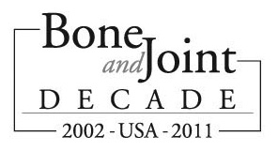
As a result of these discussions, the AAOS developed its position on this issue: Financial disclosures that display only the name of the physician and an aggregate dollar amount received without any explanation of the nature of the relationship and without educational context may be confusing and misleading to the public and patients. Specifically, AAOS believes that
Seventy-Fifth Annual Meeting
March 5-9, 2008
San Francisco, California
disclosures of implant manufacturer payments to physicians should be divided into separate categories, such as royalty payments, consulting agreements, funding for the conduct of research, funding for the support of medical education, and that these terms should be defined so that patients and the public can understand them. AAOS supports disclosure that is fair and includes a principled education context that is understandable to patients and the public.

On October 29, Dr. Rankin and I, along with AAOS’s CEO Karen Hackett, and outside counsel Kathleen (Katie) McDermott met with Christopher J. Christie, US Attorney for the District of New Jersey, and his staff, and reiterated the AAOS position. The position of AAOS was treated with respect, but was not adopted by the US Attorney.

AAOS Resources
The AAOS Board of Directors believes it is critical to monitor the effect of these disclosures on patient care and physician relationships with their colleagues and institutions. We have established a Disclosure Hotline at IndustryConflicts@aaos.org, and encourage you to use it to share your experiences, positive or negative, regarding these disclosures.

AAOS leadership also wants to ensure that our members know and understand what appropriate relationships between physicians and implant manufacturers entail. To this end, AAOS will conduct a Webinar titled “Orthopaedists at Risk: Navigating Industry Relationships” on November 13, 2007, at 8 p.m. ET, 7 p.m. CT, 6 p.m. MT, and 5 p.m. PT. I will be the Moderator. This is a free program. Members can earn 1.5 CME credits by taking part in this 90-minute online seminar. Participants will receive a comprehensive overview of the Standards of Professionalism on Orthopaedist-Industry Conflicts of Interest, as well as hear about emerging developments regarding the DOJ investigations. Register at www.aaos.org/industryrelationships For CME credit, you must pre-register; registration closes November 7, 2007.

It is possible that current and prospective patients will ask you questions about the settlement and about the names posted on the implant manufacturers’ websites. Patients may ask these questions even if your name is not posted and regardless of whether you perform procedures involving artificial knees and hips. To address this possibility, AAOS has developed several patient communication tools for your consideration.

- Patient Discussion Guide—This discussion guide is intended to give you the facts and information you need when having discussions with patients and answering their questions. The guide includes a copy of the AAOS Standards of Professionalism on Orthopaedist-Industry Conflicts of Interest. We want you to have a copy of this statement to share with your patients if these events compel you to underscore the strength of the existing ethical guidelines that govern all AAOS members.

  - Model Patient Disclosure Letter—This is a model letter that your office could modify to reflect your individual circumstances regarding financial arrangements and/or consulting agreements with implant manufacturers.

Media Questions
AAOS has developed the attached Media Statement on this matter, which we will be providing to reporters. As an AAOS member, you may receive calls from local or national media outlets seeking your comment on the release of these names by the companies or on related issues. Feel free to share the AAOS statement with members of the press who may contact you.

AAOS encourages that members refer press calls to the media relations professionals in our office. If you receive such a call, please feel free to refer the reporter to Catherine Dolf at (847) 384-4034, dolf@aaos.org or Lauren Pearson at (847) 384-4031 lpearson@aaos.org.

AAOS believes that orthopaedic surgeons will continue to share their unique knowledge and skills to develop new devices and technologies for the betterment of our patients. Our priority has been and will always be our patients.

Sincerely,

James H. Beaty, MD
President, AAOS

Attach.

News Release
FOR IMMEDIATE RELEASE CONTACT:
October 31, 2007 Catherine Dolf
(847)-384-4034 (o)
(847) 894-9112 (c)
dolf@aaos.org
Lauren Pearson
(847)-384-4031 (o)
(224) 374-8610 (c)
lpearson@aaos.org

American Academy of Orthopaedic Surgeons Issues Statement on Partnerships Between Physicians and Implant Manufacturers
Rosemont, IL – James H. Beaty, MD, president of the American Academy of Orthopaedic Surgeons (AAOS), issued the following statement in regard to the disclosure by five surgical implant manufacturers of financial relationships they have with physicians. The financial disclosures were made as part of a settlement with the U.S. Attorney for the District of New Jersey.
“AAOS supports appropriate financial disclosures to patients regarding relationships between orthopaedic surgeons and implant manufacturers. The priority of AAOS members is the care and well being of their patients. We are committed to making sure that patients and the public have confidence that partnerships between companies and physicians put the interests of patients first.

“It is important to understand that the appearance of a physician’s name on any financial disclosure filings indicates only that he or she has received compensation from the manufacturer. Many different financial relationships between members and implant manufacturers result in compensation, including providing consulting advice, conducting research, and educating orthopaedic surgeons and the public. A number of our members are also engaged in developing new medical devices to better serve patient needs. A number of these relationships result in royalties for innovative implant design.

“The scientific partnerships that some of our members have with implant manufacturers have helped develop devices that have improved the lives of millions of patients. These developments include improvements in prosthetic materials that make joint replacements last longer; design enhancements that provide better hip and knee mobility and more normal joint function; advances in prosthetic joint instrumentation that enable surgery to be done through less-invasive ways, which accelerates surgical recovery and minimizes muscle damage; and use of integrated computer-assisted surgery technology that improves reliability for total joint replacements.

“The United States is a world leader in the development of new orthopaedic technologies and techniques in large part because orthopaedic surgeons have used their unique knowledge and skills in collaboration and partnership with implant manufacturers.

“These beneficial and important partnerships between doctors and implant manufacturers must continue in order to develop new therapies, better instruments, improved implants and better patient outcomes.

“AAOS holds its members to extremely high ethical standards to ensure that even the appearance of a conflict of interest does not jeopardize the trust that patients place in our doctors. There is no place for illegal and unethical arrangements where compensation to a physician greatly exceeds the value of the services to the company. These arrangements erode public trust and confidence.

“AAOS is committed to strengthening ethical standards for our profession, and has been engaging our members with the AAOS Code of Medical Ethics and Professionalism over the past two decades. Our Standards of Professionalism on Orthopaedist-Industry Conflicts of Interest exist to ensure that all of our members understand how to identify and avoid potential conflicts of interest, and specifically address the relationship between orthopaedists and implant manufacturers.

“These Standards require AAOS members to identify and disclose potential conflicts of interest to their patients, the public and colleagues. These Standards also clearly articulate how and under what circumstances our members may work with and be compensated by implant manufacturers, as well as the penalties for failure to comply.

“We will continue to educate all of our members on how to comply with these Standards, and how to identify and resolve potential conflicts. AAOS members must adhere to these Standards as a condition of membership, and AAOS can discipline a member for violating the Standards of Professionalism, with penalties that range from censure to suspension to termination of AAOS membership.

“Our priority has been – and remains – our patients.”

The AAOS Standards of Professionalism can be found at: http://www.aaos.org/industryrelationships

###
With more than 30,000 members, the American Academy of Orthopaedic Surgeons (www.aaos.org) or (www.orthoinfo.org) is the premier not-for-profit organization that provides education programs for orthopaedic surgeons and allied health professionals, champions the interests of patients and advances the highest quality musculoskeletal health. Orthopaedic surgeons and the Academy are the authoritative sources of information for patients and the general public on musculoskeletal conditions, treatments and related issues. An advocate for improved patient care, the Academy is participating in the Bone and Joint Decade (www.usbjd.org) – the global initiative in the years 2002-2011 – to raise awareness of musculoskeletal health, stimulate research and improve people’s quality of life.

